Flexi Conference REGISTRATION USER MANUAL

LOG IN
To make a login, enter your username and password in the textbox provided.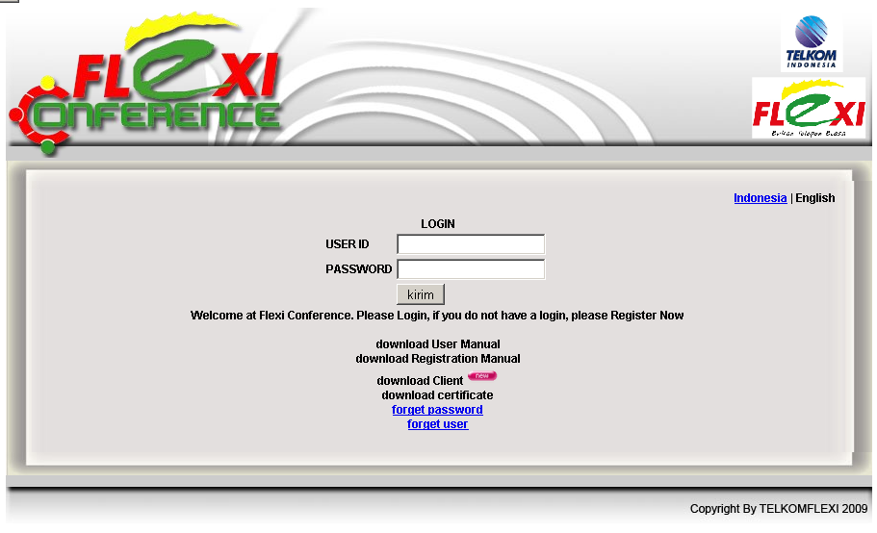
REGISTER
If you have not registered, click the registration button. Then enter your mobile phone no to get the registration code verification.
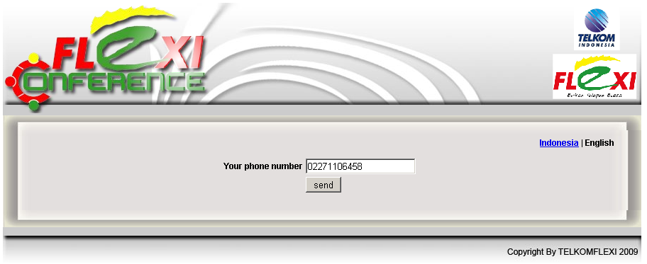
After getting the registration code verification through messages sent via SMS, enter the authentication and enter the Full Name, User Name, Password, Enter a password again and select the registration status to normal.
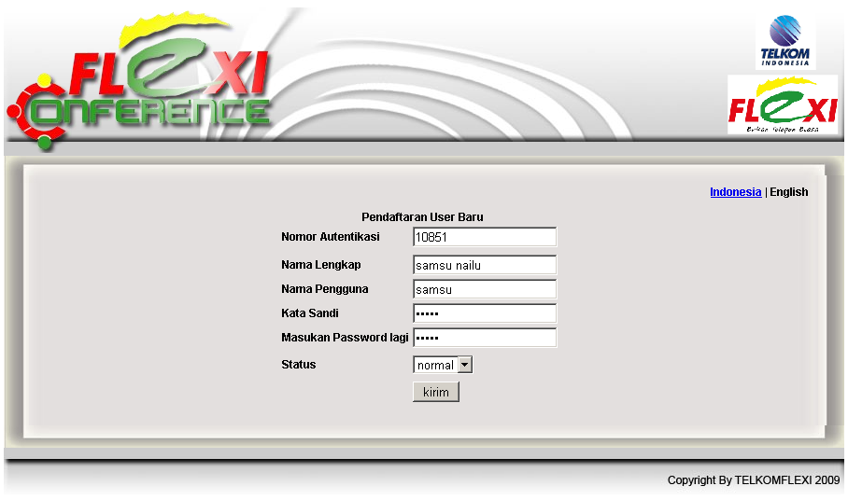
After successfully registering a User ID and Password, log on the page https: / / conference.telkomflexi.com / user_login.php use the User Name (User ID) and Password (Password) of new registrations.
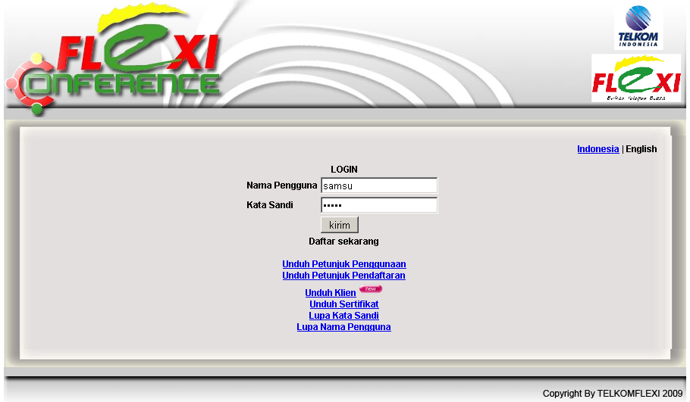

General Info
After successfully logging in, in the tab "General Info" (https: / / conference.telkomflexi.com / user_basic.php), you can change or delete your member, you also can change the capacity Address Book / Address Book (maximum 1000). Pastikan Status anda adalah “normal“. Make sure your status is "normal."
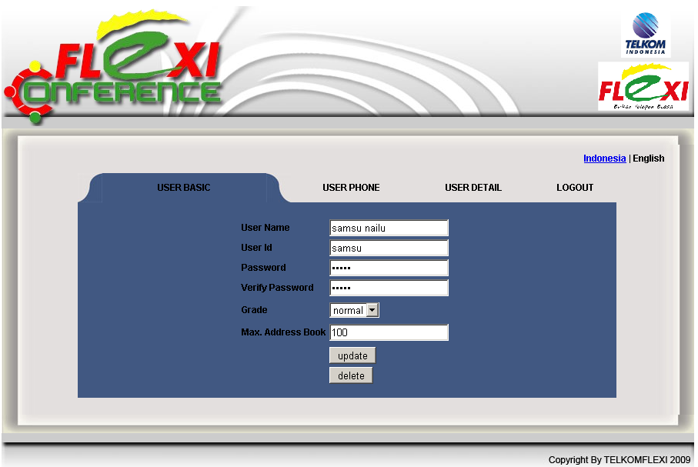
Phone Info
Tab "Phone Info" (https: / / conference.telkomflexi.com / user_phone.php) describes the information that details the phone number registered member concerned.
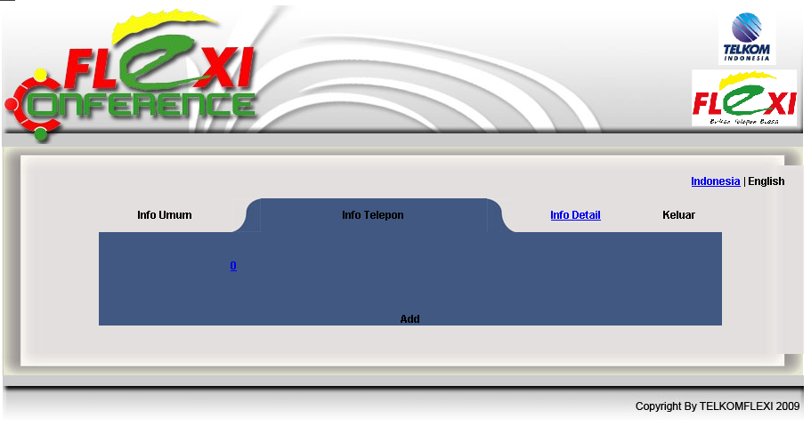
To add details of the phone, click the button "Add." Fill in the textbox to add the phone number that will be registered. You will receive an SMS verification code contains the addition of numbers.
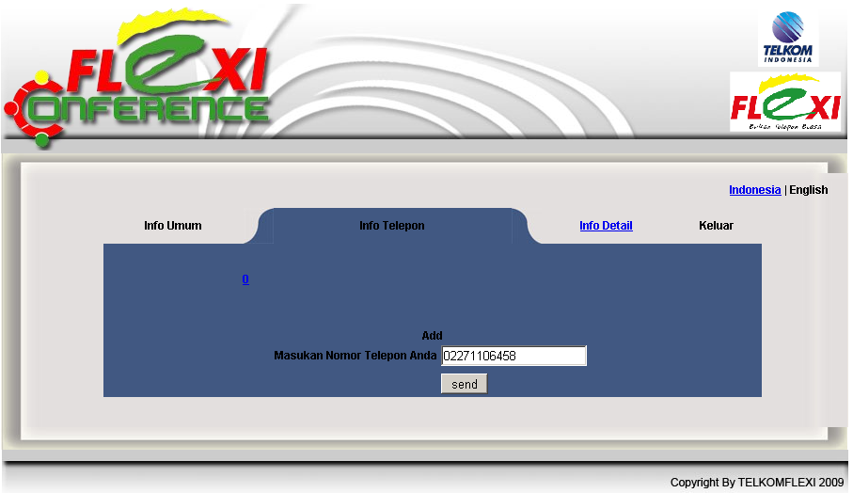
Fill in the validation of adding the number obtained with via SMS Name Location details and click the "add".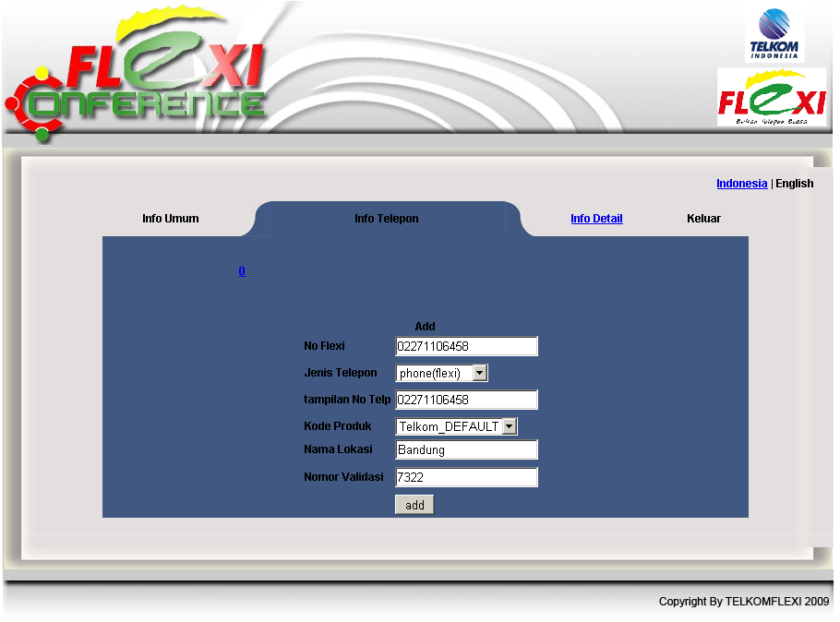
If the addition is successful, then the tab "Phone Info" will be shown 2 that the line containing the number Searched added.
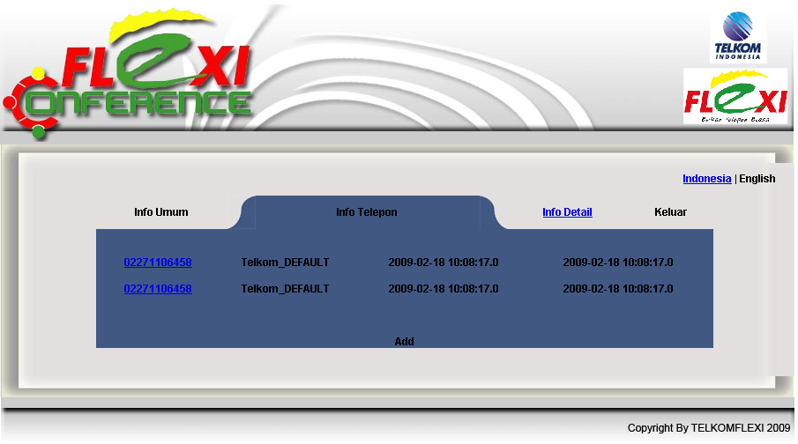
If the member wanted to make changes or add details or delete the number the number that has been registered, click on the number in question.
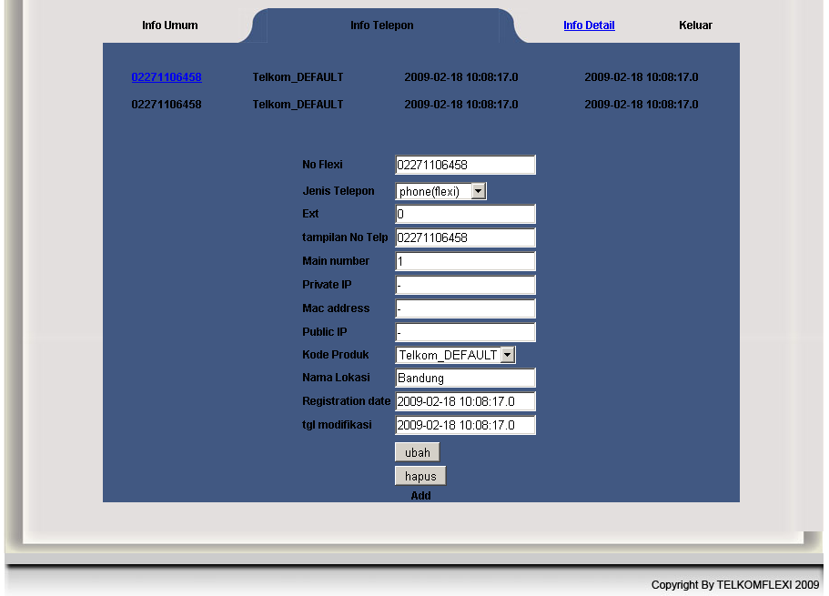
Info Detail Detail Info
Tab "Detail Info" (https: / / conference.telkomflexi.com / user_detail.php) contains detailed member information. If the member does not yet have detailed info, click on the "make new user detail"
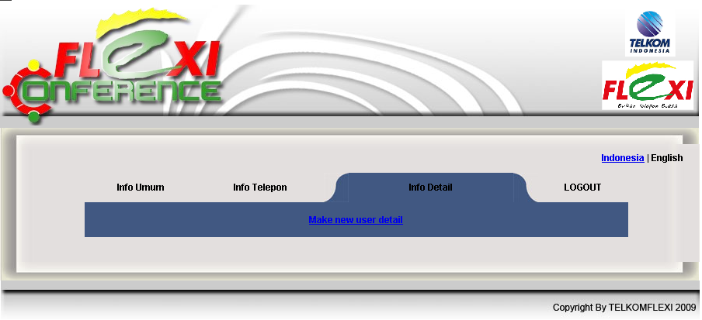
Fill in the textbox provided details about the member concerned.
If you have filled in, click the "Add".
Member can update the details of the recorded information by clicking the info is already saved and click on the update button.
If the member concerned that this would end the web, click the "Exit" or "Log Out". And if the member concerned would change the language to English, or vice versa, click the button or in the English top-right corner.

